

We provide Essex residents (excluding Southend-On-Sea and Thurrock) access to health checks, stop-smoking services, weight management courses and emotional health and wellbeing support - including support for carers.

# Because carers need care too

We understand that being an unpaid carer can be stressful and challenging. Your wellbeing could be impacted while you’re doing your utmost to care for an elderly relative or an in-need loved one.

Caregivers often find they have less time for themselves and other family members. They often spend so much time on caregiving duties that they end up sacrificing the things they enjoy, like hobbies or holidays. They may also have trouble balancing work schedules around caregiving.

At the Essex Wellbeing Service, we have people who can **listen** to your concerns and challenges and help you find **support and advice** relevant to your needs. We appreciate that life can be difficult, and it can be challenging to find the right support for your circumstances.

Talk to someone about your caring role

If you are looking for support in your caring role, we are your first port of call. We offer a **confidential phone call** to discuss your situation and work with you to find the best support.

The Essex Wellbeing Service provides the following advice, information and guidance to carers living in Essex:

* Information on the support that is available to you as a carer in Essex
* Information on local support groups and services in your area
* Advice that is specific to you and your situation
* A referral for a carers assessment, where appropriate.

Get in touch

You can complete our online assessment to help you understand more about your health needs, prioritise them and find the right support for you – visit us at **https://assessment.essexwellbeingservice.co.uk**.

Alternatively, if you would like to speak to someone about any of our services or would like assistance taking the assessment online, please contact us on **0300 303 9988** to talk to one of our friendly team members or email us at **provide.essexwellbeing@nhs.net.**

We are open **Monday to Friday 8.00am – 7.00pm**, and **Saturday 9.00am – 12.00pm**.

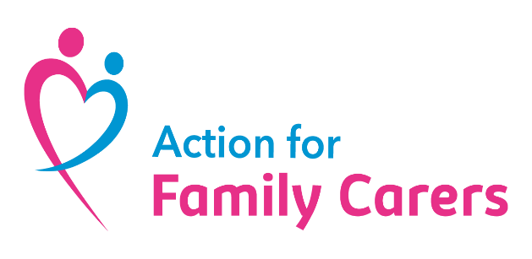  

**How can we help?**

Action for Family Carers, in partnership with Essex Carers Support, has been commissioned by Essex County Council to deliver support for Adult Carers in West Essex (Epping, Harlow & Uttlesford districts) and Northeast Essex (Colchester & Tendring districts).

As detailed on a separate sheet in your pack, there is a **central online contact point** for carers run by the Essex Wellbeing Service. You can also **call 0300** **303 9988** to discuss your caring role and receive information, advice and guidance tailored to your needs.

If more **specialist support** is required, Action for Family Carers (West and North Essex) can provide more tailored help to meet your needs.

We can offer:

* Information, advice and guidance
* Practical solutions to address specific challenges
* Support for your emotional wellbeing
* A free counselling service
* Small grants to enable you to take a break from the pressures of caring
* Opportunities to connect with other local carers at Peer Support groups.

**How do I contact you?**

You can self-refer by completing an online form at **affc.org.uk/make-a-referral**

Or you can call us on **0300 770 80 90** and speak to one of our friendly team.

Our opening hours are **Monday – Friday 9.00am – 5.30pm** and **Saturday 9.00am – 12.00pm**